Login - Inventory Management System:

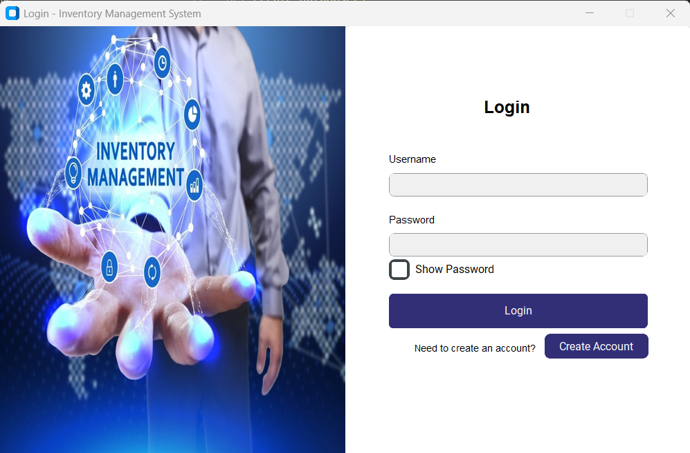

**Functionality:**

* Allow users to enter username and password.
* Validates credentials against the MySQL user’s table.
* Displays error if credentials are invalid or fields are empty.
* Redirects admin users to the Admin Dashboard.
* Redirects customer users to the Customer Dashboard.
* Provides a button to create a new user account.

Sign Up:

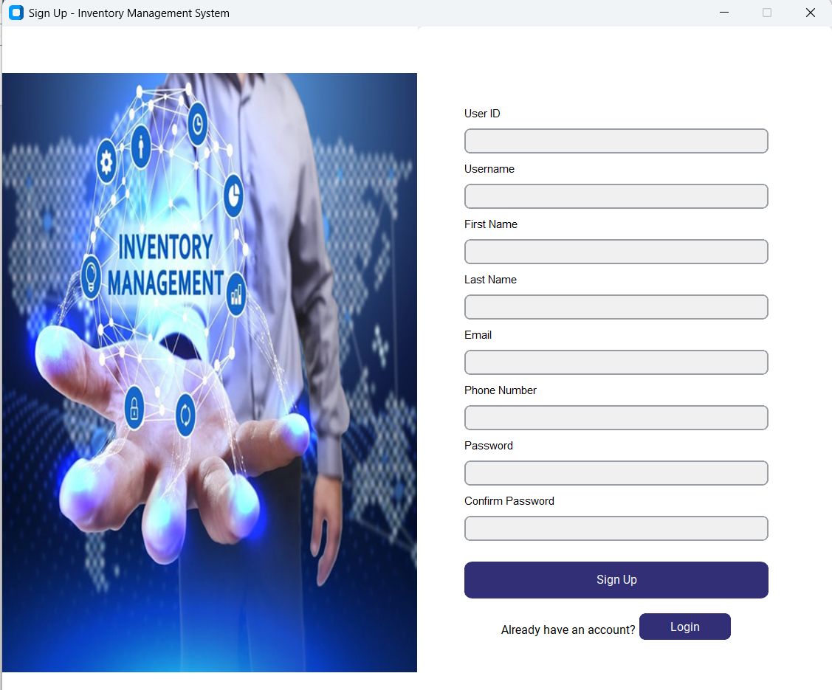

**Functionality:**

* Allows new users to register with personal and login details.
* Validates input fields (email, phone, password strength, etc.).
* Checks for existing user ID, username, or email in the database.
* Saves new customer record to the MySQL database if valid.
* Shows success message and redirects to login on successful sign-up.
* Provides a button to switch to the login screen.

**Customer Dashboard**

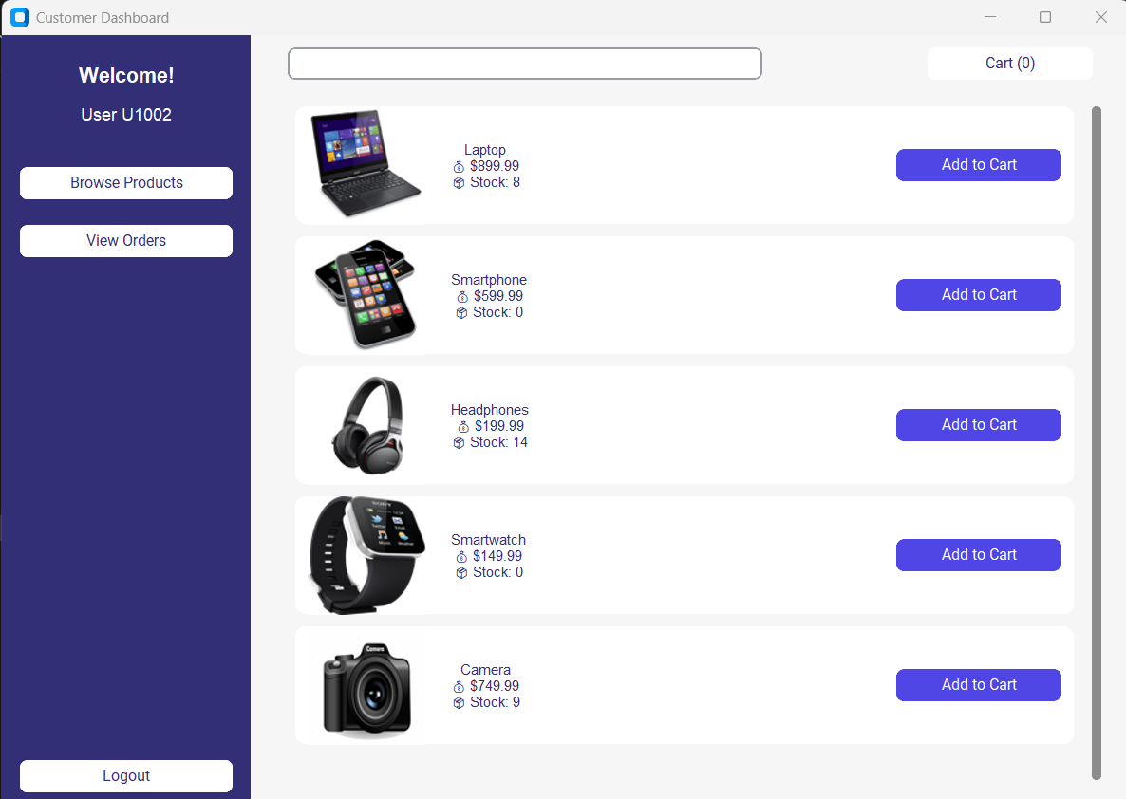

**Functionality:**

* Displays a personalized dashboard for logged-in customers.
* Allows browsing available products and adding them to the cart.
* Enables viewing of previous orders.
* Dynamically updates the product list and cart count.
* Sidebar provides navigation and logout functionality.
* Automatically redirects to the login screen on logout.

**Cart**

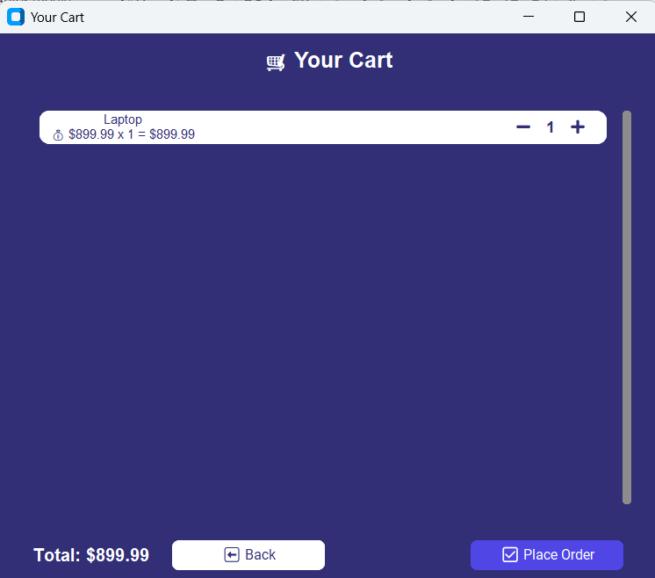

**Functionality:**

* Displays all items currently added to the user's cart.
* Allows adjusting product quantities directly from the cart.
* automatically updates the total price in real-time.
* Enables placing an order and updating stock in the database.
* Show’s success/error messages upon checkout.
* Provides a back button to return to the customer dashboard.

**Your Orders**

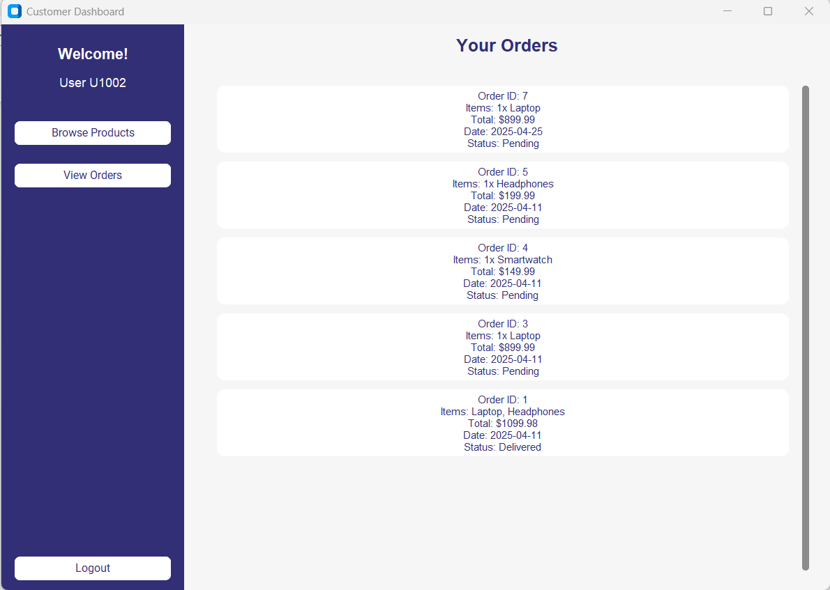

**Functionality:**

* Displays a list of all past orders placed by the logged-in user.
* Shows order details like ID, items, total amount, date, and status.
* Use scrollable layout for better readability on multiple orders.
* Fetches data directly from the database using the user's ID.
* Automatically formats and presents each order in a styled card.
* Helps users track pending or delivered purchases efficiently.

**Admin Dashboard**

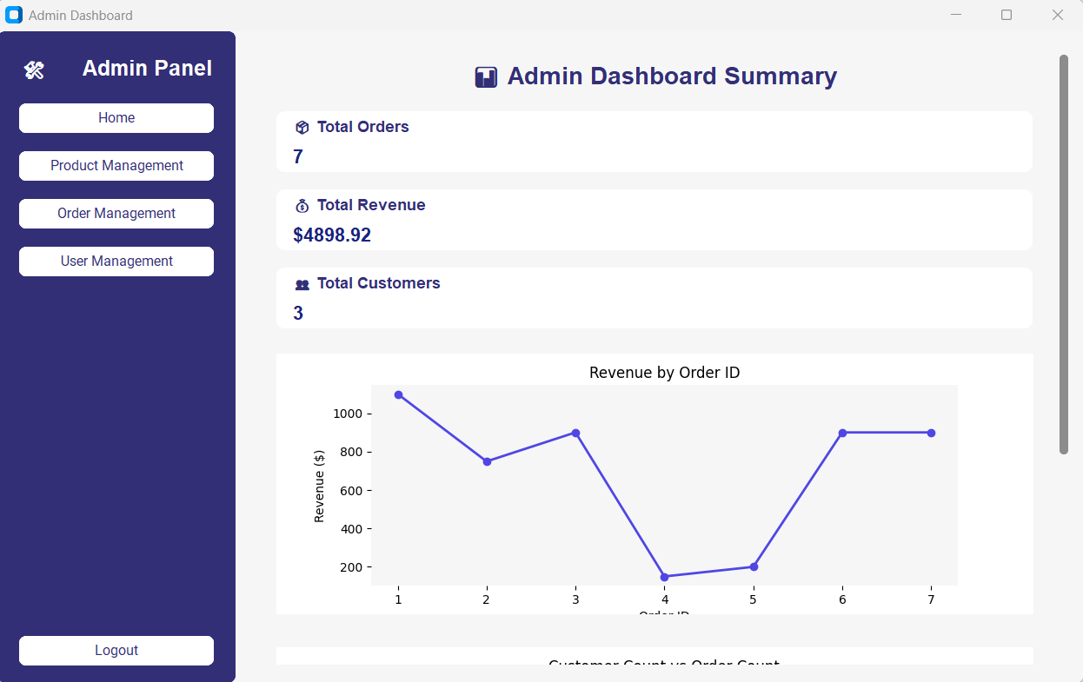

**Functionality:**

* Displays summary KPIs: Total Orders, Revenue, and Customers.
* Shows dynamic graphs: Revenue by Order ID and Customer vs Order count.
* Allows exporting the dashboard data and graphs into a downloadable PDF report.
* Provides quick navigation to Product, Order, and User Management.
* Pulls all data live from the database for accuracy.
* Designed for admin users to monitor system health and activity efficiently.

**Manage Products**

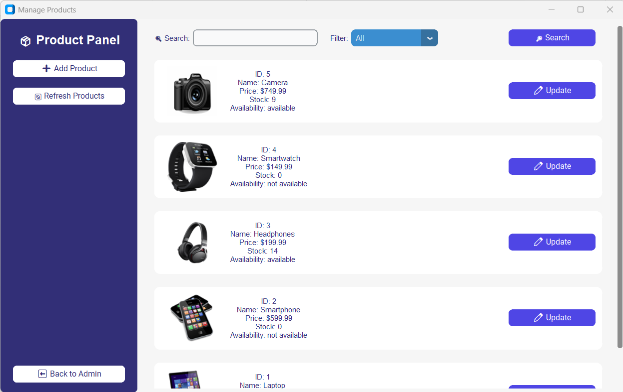

**Functionality:**

* Displays all products in a scrollable list with image, name, price, stock, and availability.
* Allows filtering by availability and searching by product name.
* Admin can add new products with image, price, stock, and description.
* Existing products can be updated using a popup form.
* Provides real-time database integration and reflects changes instantly.
* Designed for admins to manage inventory efficiently within the dashboard.

**Manage Users**

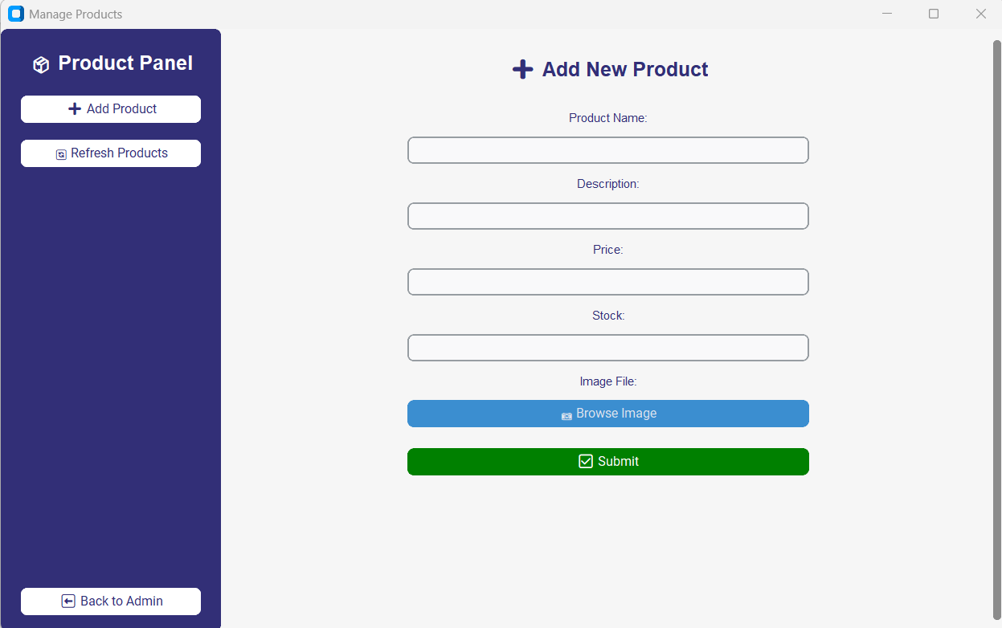

**Functionality:**

* Displays all registered customer users with search and filter options.
* Allows the admin to add a new user with details like name, email, and password.
* Supports editing of existing user information and status (active/inactive).
* Fetches user order history and displays total orders and items.
* Real-time database updates and user management functionality.
* Seamlessly navigates back to the admin dashboard.

**Order Management**

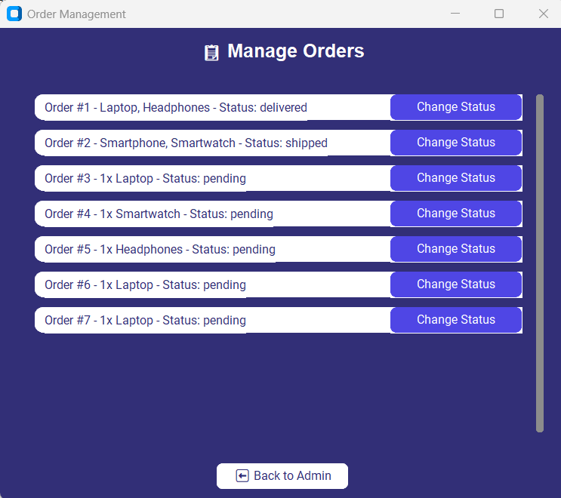

**Functionality:**

* Displays a list of all customer orders with current statuses.
* Allows admin to update the status (e.g., pending → shipped → delivered).
* Status changes are saved directly to the database.
* Scrollable layout for managing many orders.
* Shows item names and quantity per order clearly.
* Includes a back button to return to the admin dashboard.

Manage Users:

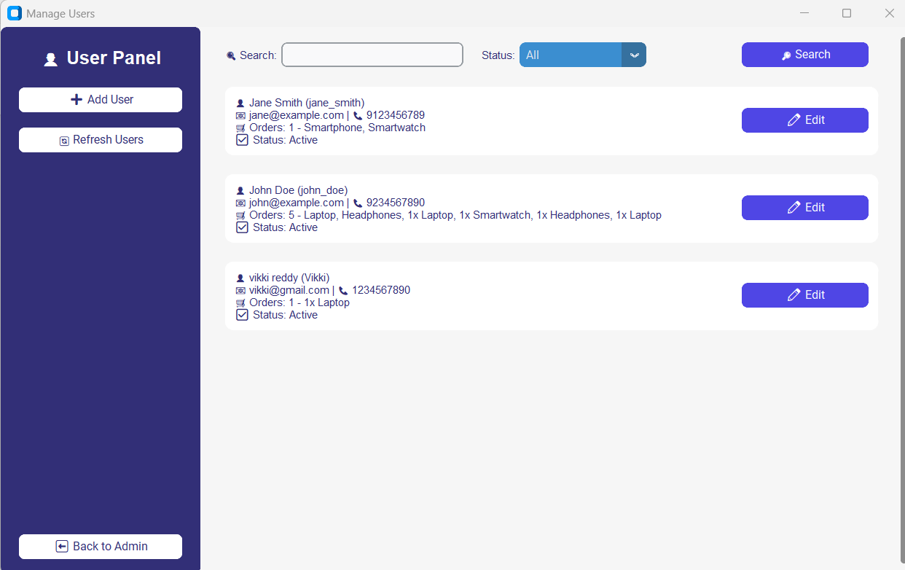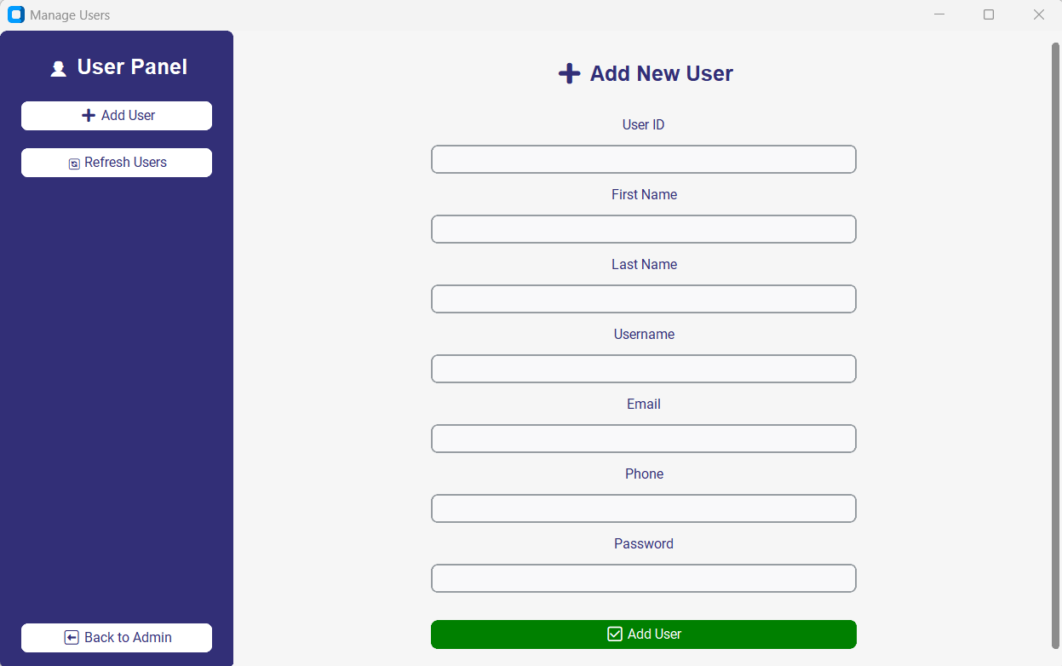

**Functionality:**

* Displays a list of registered users with full details: name, username, email, phone, order history, and status.
* Provides a search bar to filter users by name or username and an option menu to filter by status (Active/Inactive).
* Each user card includes an **Edit** button to update user details (email, phone, status).
* An **Add User** form allows admins to register new users by filling in basic credentials (User ID, Name, Email, Password, etc.).
* Ensure user data is synced with the backend database using get_db_connection().
* Offers quick refreshment of user data and navigation back to the Admin Dashboard.